ERD Diagram:
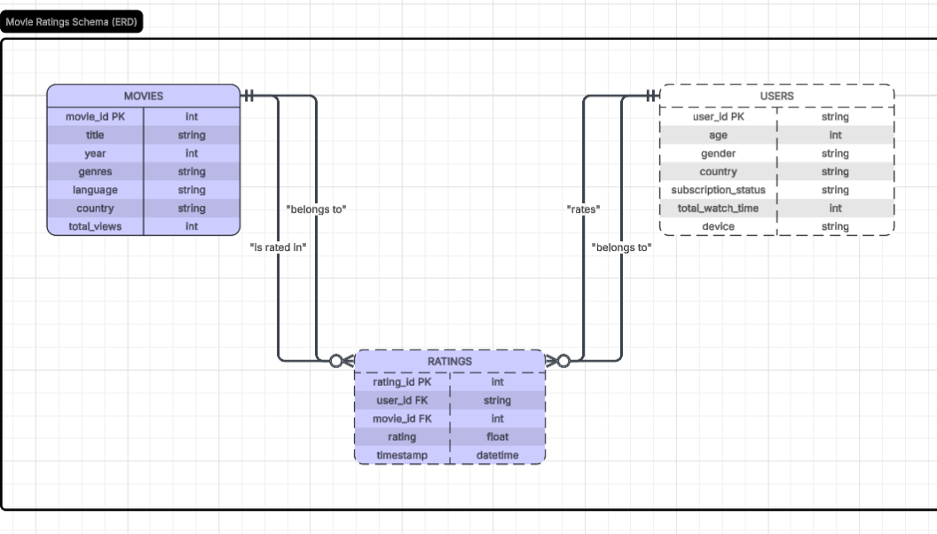
Schema design:
Users
- user_id (PK)
- age
- gender
- country
- subscription_status
- total_watch_time
- device
Movies
- movie_id (PK)
- title
- year
- genres
- language
- country
- total_views
Ratings
- rating_id (PK)
- user_id (FK → Users.user_id)
- movie_id (FK → Movies.movie_id)
- rating
- timestamp
Relationships:
- One user can have many ratings
- One movie can have many ratings
- Each rating belongs to exactly one user and one movie

SQL TABLE SCRIPT

CREATE TABLE Users (
user_id VARCHAR(20) PRIMARY KEY,
age INT,
gender VARCHAR(10),
country VARCHAR(50),
subscription_status VARCHAR(20),
total_watch_time INT,
device VARCHAR(20)
);

CREATE TABLE Movies (
movie_id INT PRIMARY KEY,
title VARCHAR(255),
year INT,
genres VARCHAR(255),
language VARCHAR(50),
country VARCHAR(50),
total_views INT
);

CREATE TABLE Ratings (
rating_id INT PRIMARY KEY,
user_id VARCHAR(20),
movie_id INT,
rating DECIMAL(2,1),
timestamp DATETIME,
CONSTRAINT fk_ratings_users
FOREIGN KEY (user_id) REFERENCES Users(user_id),
CONSTRAINT fk_ratings_movies
FOREIGN KEY (movie_id) REFERENCES Movies(movie_id)
);

